3 Concorde Gate, Suite 302, Toronto, Ontario, M3C 3N7
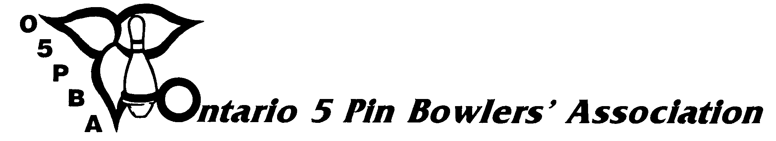
Telephone: (416) 426-7167 Fax: (416) 426-7364 E-Mail: o5pba@o5pba.ca Website: www.o5pba.ca

ONTARIO OPEN 5 PIN BOWLING CHAMPIONSHIPS
ONTARIO OPEN 5 PIN SENIORS CHAMPIONSHIPS

ENTRY FORMS AND TOURNAMENT SITES INFORMATION

The information requested on this form must be received in the Provincial Office on or before OCTOBER 16, 2015.

ZONE ASSOCIATION:

TOURNAMENT DIRECTOR:

DATE OF REPORT:

ENTRY FORMS
INFORMATION FOR THE CENTRE OF THE ENTRY FORMS
INFORMATION RE PERSON TO WHOM ENTRIES ARE TO BE SENT:

NAME:
ADDRESS:
CITY/TOWN: |  | POSTAL CODE:
E-MAIL ADDRESS: |  | TELEPHONE NUMBER:
ENTRY FEE:
DEADLINE DATE:

ONTARIO OPEN 5 PIN BOWLING CHAMPIONSHIP SITES

DATE | REGISTER  TIME | START  TIME | BOWLING CENTRE | MEN | LADIES

If your Association is holding the Seniors Division of the Open on a different date and location, please provide the required information below. Every attempt will be made to ensure that separate information on the Seniors Division will be included on your entry form. Space is limited.

ONTARIO OPEN 5 PIN SENIORS CHAMPIONSHIP SITES

DATE | REGISTER TIME | START TIME | BOWLING CENTRE | MEN | LADIES

Option #1: Please try to include our Seniors Division information on our Regular Open Form

Option #2: Please provide separate “Seniors Division” Entry Forms

I AM REQUESTING THAT THE ENTRY FORM BE E-MAILED TO ME AND I WILL DOWNLOAD AND PRINT COPIES
Please Indicate: Yes ( ) No ( )

IF YOU ANSWER NO, HOW MANY COPIES OF THE ENTRY FORM DOES YOUR ASSOCIATION REQUIRE?

REGULAR OPEN FORMS: ____________________

SENIORS DIVISION FORMS: ____________________

